Project 2:

Part I:

1. Write a map reduce program to remove commas present inside the double quotes.

Task class:

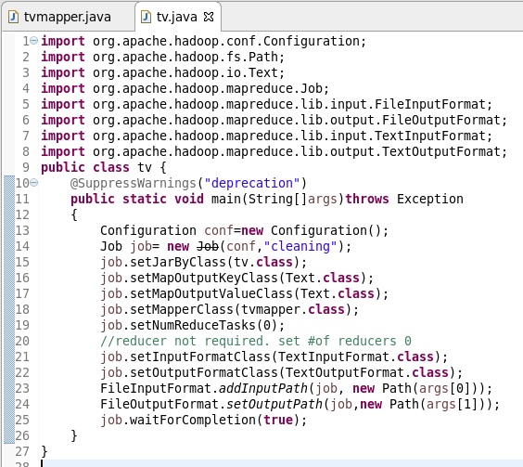

Mapper class:

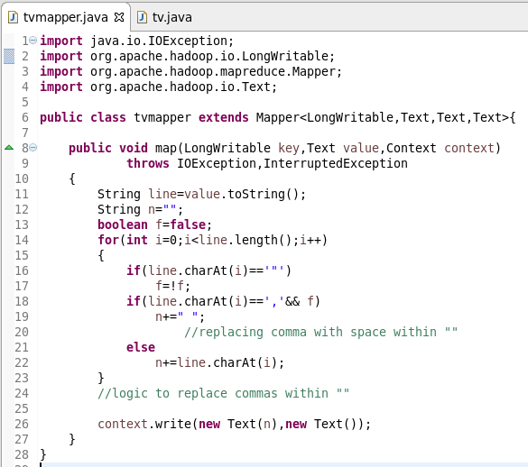

Explanation:

The above map reduce program will eliminate the commas present within the “ “ so that it will be easy to split the data using “,” in pig script. The commas within “ ” indicate sub-columns of a particular column.

Part II:

1. Write a pig script to find no of complaints which got timely response
2. Write a pig script to find no of complaints where consumer forum forwarded the complaint same day they received to respective company
3. Write a pig script to find list of companies topping in complaint chart (companies with maximum number of complaints)
4. Write a pig script to find no of complaints filed with product type has "Debt collection" for the year 2015

Pig script for above problems:

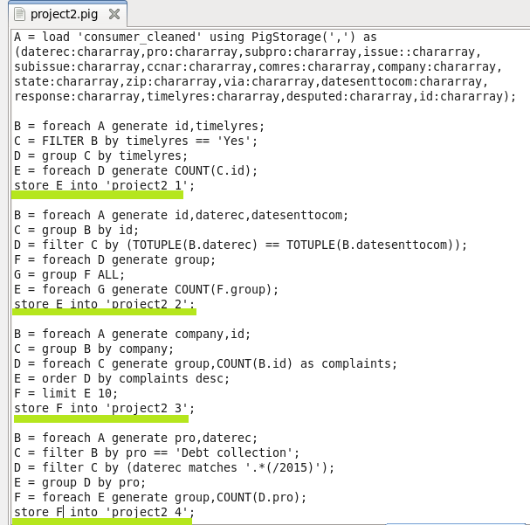

Running pig script:

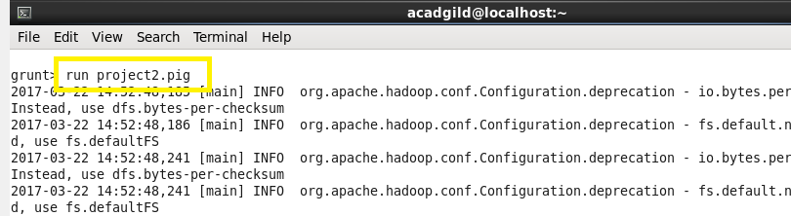

Output problem 1:

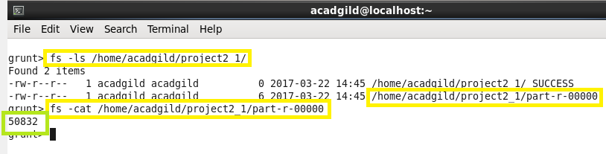

Output problem 2:

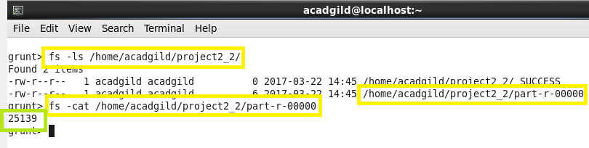

Output problem 3:

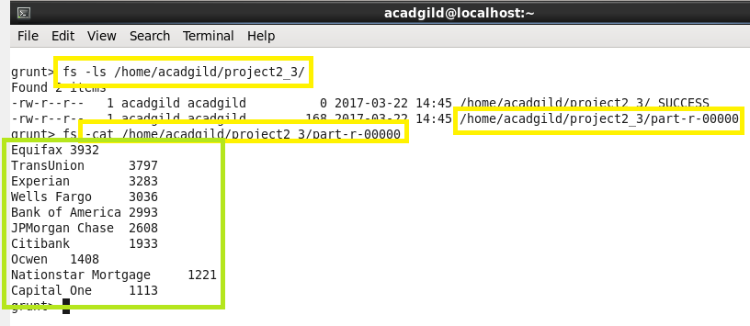

Output problem 4:

